Contents

Assumptions 2

Technical Solution 2

Security Configuration 2

Security Role 2

Contact Centre 2

Entity Updates for Customization 3

Entities Updates 3

Follow-Up Activity 3

Validation 4

Prevent CS Agent from closing case as resolved. 4

Only Customer Service Agent can mark a Case as Confidential 4

Only a Customer Service Manager can mark a Case as Escalated 4

# Assumptions

1. There is a Single Escalation Team and Confidential Case Team present for all Contact Centres.
2. All documents related to Case, Contact, Activities is stored on SharePoint.
3. All users are not allowed to delete Records
4. A case can either be marked as Escalated or Confidential and not both.
   1. Case can only be escalated by a Customer Service Manager
   2. Case can only be marked as confidential by a Customer Service Agent.
5. If the case is assigned to an incorrect ‘Contact Centre’, it needs to be escalated and sent to Escalation team.

# Technical Solution

## Security Configuration

### Security Role

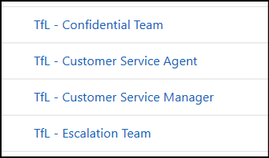

1. TfL – Confidential Team: For confidential team to access the app and case assigned to them
   1. Can read other cases assigned to Confidential team
2. TfL - Customer Service Agent: to receive & classify case.
   1. Customer Service agent will receive and route the case
   2. They can access all cases within their Business Unit.
3. TfL - Customer Service Manager: to resolve case and escalate cases
   1. They can access the cases assigned to them only
   2. They can access Follow-up Tasks created for Confidential Team
4. TfL – Escalation Team: For Escalation team to access the app and case assigned to them
   1. Can read other cases assigned to Confidential team
5. Assign roles to the App – ‘Customer Service Hub’
6. Setup Role Persona Mapping as shown below

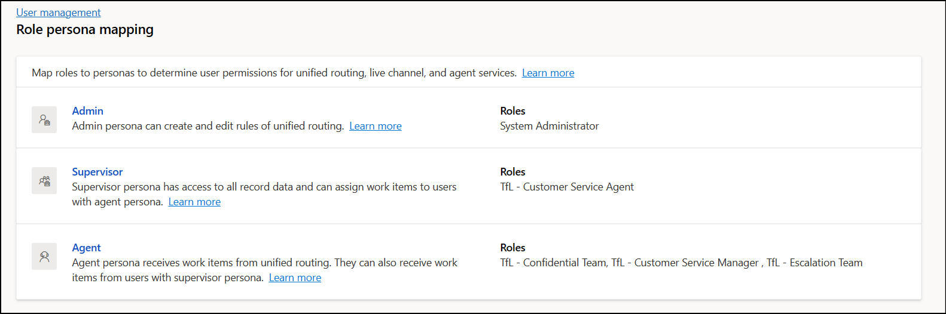

### Contact Centre

1. Create Business Unit TfL Operations under the Base Business Unit
2. Business Centre in Dataverse as part of security administration
   1. Contact centres - Underground, Buses, Overground
   2. Escalation Team
   3. Confidential Team

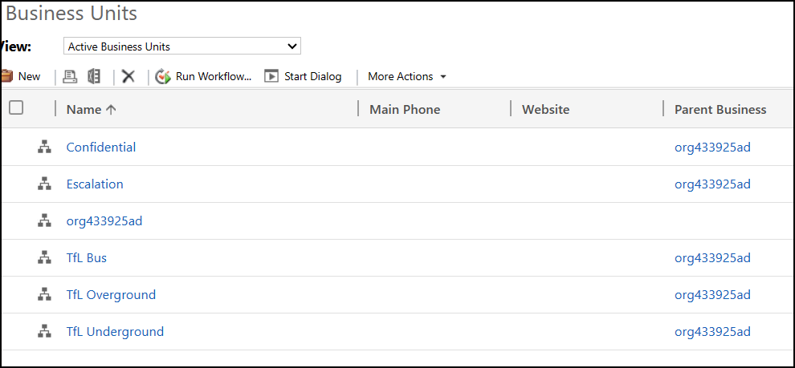

1. Add Customer Service Managers will be added to respective Business units - TfL Bus, TfL Underground and TfL Overground
2. Add Confidential and Escalation Team to the Corresponding Business Units.
3. Add Agents to the root Business Unit.

## Entity Updates for Customization

### Entities Updates

* 1. Case

|  |  |  |  |  |
| --- | --- | --- | --- | --- |
| **Custom** | **Display Name** | **Field Type** | **Values** | **Description** |
| Added | ‘Is Confidential?’ | Choice | Yes/ No | For Customer Service Agent to mark the Case as confidential |
| Added | ‘Assign to Contact Centre’ | Lookup | Business Unit | For Customer Service Agent to Assign case to the correct Contact Centre’. Filtered view of Business unit. |
| Added | Additional Information for Team | Multi-line Text | Text | For Customer Service Manager to fill in details before transferring the task to Escalation or Confidential Team |
| Added | Case Manager | Lookup | User | To track the Case Manager after assigning case to Escalation or Confidential team |
| Modified | Case Stage | Choice | * + 1. Assigned to Manager     2. Escalated     3. Confidential | To track current stage of the Case. This is a read only field. Updated through work Classification rules. |

* 1. Task

|  |  |  |  |  |
| --- | --- | --- | --- | --- |
| **Custom** | **Display Name** | **Field Type** | **Values** | **Description** |
| Added | ‘Is Confidential?’ | Choice | Yes/ No | For tracking follow-up task related to Confidential Case |

## Follow-Up Activity

1. Task will be used for performing Follow-Up Activity
   1. A workflow is executed when a case is marked as Escalated/ Confidential and routed by the Manager.
2. Create Access Template for Task Entity.
   1. This will be used to provide access for Case Mangers for follow up activity related to Confidential cases
   2. Case Managers will be added to the Access team when a new task is created after the Case is assigned to Confidential Team
      1. This will be done through Plugin and added on create of Task.

## Validation

### Prevent CS Agent from closing case as resolved.

Create a workflow to prevent Customer Service Agent from closing case as resolved. This is tracked on create of Case Resolution.

### Only Customer Service Agent can mark a Case as Confidential

A Business rule is used to prevent this. ‘Is Confidential’ field can only be modified when the Case stage is ‘Default Value’.

### Only a Customer Service Manager can mark a Case as Escalated

A Business rule is used to prevent this. ‘Is Escalated’ field can only be modified when the Case stage is ‘Assigned to Manager’.

### Additional Information for Team and Follow-Up by Date

Validation is done through JavaScript. The function checks if the case has been escalated or marked as Confidential and makes both fields mandatory before creating a Task for Escalation or Confidential Team user.

## Routing Configuration

1. Create a Workstream for each 3 contact Centres, Escalation Team and Confidential Team
   1. Create an Intake rule
   2. Create Work Classification rule to update the Case stage to ‘Assigned to Manager’/ Escalated/ Confidential
   3. Create a Fallback Queue for the Contact centre, add users to it and a ruleset to assign the case to the queue.

# Functionality

1. When a Case is created, agent update the Contact Centre to which the case should be assigned. If the case is confidential, Agent selects confidential too.
2. Then the Customer Service Agent selects ‘Save and Route’ to assign the case to the Correct Queue.
   1. When the routing happens the ‘Case Manager’ is assigned to the Case
3. All cases are assigned to One of the Contact Centres.
4. Customer Service Manager reviews the Case and starts working on it.
   1. If user is able to resolve the case. Case will be closed by the user.
   2. If the case is case is marked as Escalated/ Confidential, user should add additional information that needs to be passed on the Escalation/ Confidential Case along with a Follow-up date for the task assigned to Escalation/ Confidential Team and click ‘Save’.
5. If the Customer Service manager is unable to solve the case, the Customer Service Manager will click ‘Save & Route’.
   1. If escalated, the case is assigned to Escalation Team and a follow-up task created for them and they should resolve the case.
   2. If marked as Confidential, the case is assigned to Confidential Team and a follow-up task is created for the confidential team. ‘Case Manger’ is added to the Access team.